**Title**: Student Progression Tracker

**Team Members**: Andrew Kincaid, Shauna Doyle, Dylan Murtagh

**Duration**: 08/02/2021 - 05/03/2021

**Product Description**:

“

. “

**Project outline**

An application to record and display course/ module info., students grades and learning outcomes and records, on a windows form (windows presentation forms) and MS access database.

The application is primarily intended for use by FIT course Software development participants and may be adapted to suit other courses - the need identified by our team is a way to record results and track progress as the students are completing modules and assignments, with the ultimate goal to finish the course over a two year period. The application will be used by the student and the information will be saved to their own personal computer the data table regarding the course information will be pre-populated and the student info database will be linked via a course code which will enable students potentially lecturers to record their learning out comes, assignment test results relating to each module.

We plan to develop the application using windows forms and c#, the application will connect to some MS Access databases. Data will be manipulated by sql statements and loaded into the application to be displayed, updated, deleted and saved. We plan to have some searches which will allow some data to be displayed relating to each module and all the information regarding the module, including tasks the student carried out and results.

Our project team consists of 3 students of FIT Software Development Apprenticeship, and we are developing the software as part of a task which should help us not only tracking our results and progress but also to gain experience working on a team project, developing an application as a group and managing the task and project over the course of four weeks. We will spend week one on design and the remaining 3 weeks on the development - we are using the object oriented development paradigm, and using scrum type management style, we will have meeting on a given day and set ourselves realistic goals and tasks to achieve in short 1-2 hour sprints, over the period of four weeks the application will evolve.

**How to manage the project**

* Daily meetings maybe 2-3 short meetings to assign tasks discuss progress
* Tasks assigned and each team member works on their task for the allocated time, discusses progress, problems etc at the meeting.
* Version control - once we start implementing code.

**Design Storyboard**

* **Who is the end user?**

Students of FIT Software Dev course

* **What do they need to do with the application?**

To help track results and progress as they do their course.

* **Why would they need the application?**

It is hard to keep records of all results etc as we are dealing with different tutors, using different platforms. Also to give students an overall view of their progress as they go through the course.

* **How can they use the application**

The application can be installed and set up on the users PC and database will be stored locally. Each student will be able to log in. The application will be menu driven with some good user interface. Some information will be able to be updated and amended. Information will be displayed in various forms to help the user track progress on modules and the course overall.

* **What are the key features of the application?**

Course and module information.

Student and module records.

Student - task/ assignment records.

**Project Preliminary Design**

We intend to use C# and windows forms to develop the application the application will use two MS access databases which will store info regarding courses/ students and progress. Below is a list of potential tables and information we need to store.

**Course_DB (For version 1 this can be hard coded as it is only for our course)**

courseName

courseCode

courseTutor

courseLocation

**Module_DB (Each course has many modules)**

moduleName

moduleCode

moduleTutor

moduleInfo

moduleDuration

moduleLevel (level 3 / 4)

moduleLearningOutcome

moduleCompRequirements

**Student_DB(for version 1 student info can be hard coded to just who is the user)**

studentID

studentName

studentCourse

studentStartDate

studentProgress (??%)

studentLogIn

**Student_Progress_DB ( one student will have many modules to complete)**

studentID

moduleCode

moduleStartDate

moduleProgress

moduleResults

moduleComplete

moduleOutcome

**Student_Results_Db (one module may have several tasks to complete)**

studentID

moduleCode

moduleTask

moduleTaskDate

moduleTaskResult

moduleTaskComplete

moduleTaskLearning

Potentially a relational database - which will be stored on the individual computer and store all of the users info.

**Timeline:**

Defined project Requirements, design

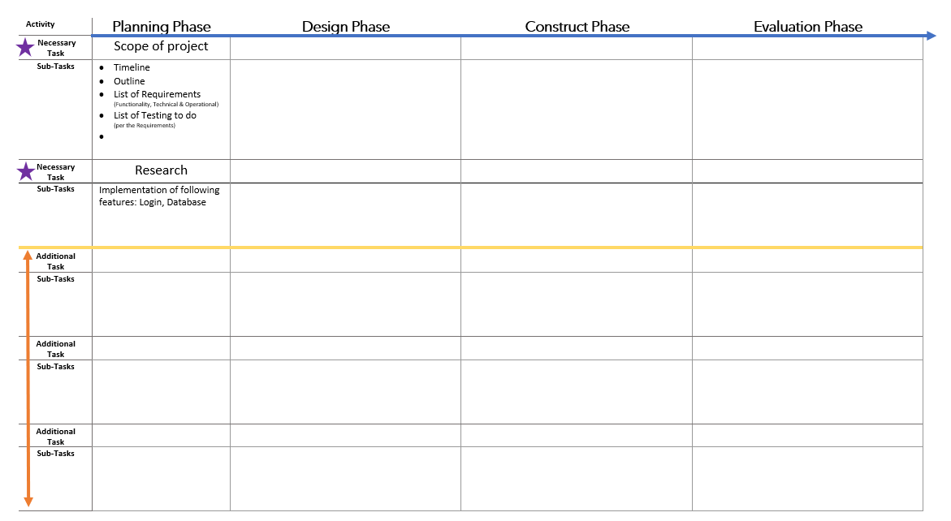

**Brief outline:**

Design phase - week 1 - 4 hours ( 9-13:00) = (4*5*3) = 60 man hours hours

Implementation phase: weeks 2-4 ( 9-16:00 Monday & Tuesday)= (126 man hours)

**Research:**

How to interact with more than one database using C# windows forms.

[C# Dataset with multiple tables - Sql Server (net-informations.com)](http://csharp.net-informations.com/dataset/dataset-multiple-tables-sqlserver.htm)

Check with deirdre tomorrow

**To do list :**

* + Create schedule (Shauna)
  + Wire frame Windows form sample - (Dylan)
  + Expand on project outline (Andrew)
  + Expand on specification (Andrew)
  + Decide on data requirements - potentially 2 data tables - course info, students learning info. (Andrew draft)
  + Test data

# GUI

